Modeling Evolution Time Scale Grade 9 Standard 8.1

Authors: Connie Everts, Yvette Wolter and Rick Roberts

Title of the Investigation: Erosion, a Timely Process

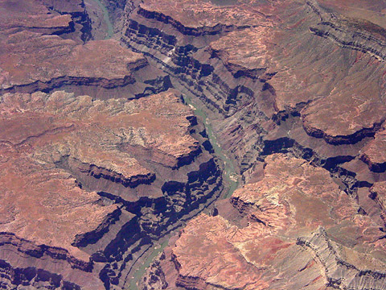

Standard: Explain how anatomical and molecular similarities among organisms suggests that life on earth began as simple, one-celled organisms about 4 billion years ago and multicellular organisms evolved later.

Leading Questions:
- If water flows by the path of least resistance, what does that mean?
- What is erosion?
- How long did it take to form the Grand Canyon?

Summary: In this activity, students will model the process of erosion on a small scale to get an idea of how long it must have taken to form the Grand Canyon. This will lay out the foundation for appreciating how old the Earth must be in order to support the timeline of the evolution of life (according to Lyell’s argument).

Equipment Used:
- Sand and Sandstone
- Buret and water
- Meterstick to mark the depth pole
- Stream Table

Description of Procedure:
- Each pair of students is assigned either sand or sandstone. These equal masses will be placed in one area of the stream table with a depth pole inserted into their sand sample.
- Using a buret opened for a constant drop flow of 8 drops per mL, students must calibrate the rate before beginning the experiment.
- They must measure any changes in depth due to the point of contact with the water after every 2 min. Continue until you have 10 data points.

Follow Up:
- Describe the flow of water through your sample—does the water pool or stream?
- Graph time vs. depth and determine how long it would take to reach a depth of 183 km.
- Do you anticipate that the Grand Canyon is getting deeper?
- Can you tie the age of the Grand Canyon with the estimated 4.6 billion year age of the earth?

